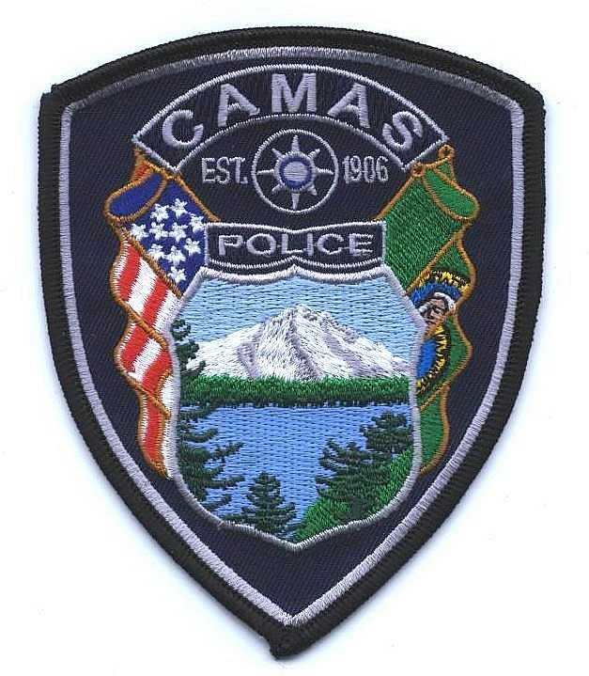
Camas Police Department
MEMO
June, 2023
To: Chief Lackey
From: Captain Nelson
Subject: Pursuit Review for 2022

There was one pursuit review in 2022, which involved a traffic stop of a vehicle that had just been reported stolen.

Administrative Review 22-10
An officer observed a vehicle that matched the description of one that had just been stolen in Washougal. The officer initially observed erratic driving, then the vehicle drove in a routine manner. The officer caught up to the vehicle as it slowed at a roundabout. As the patrol vehicle got behind it, the vehicle took off at a high rate and crashed into another vehicle. The suspect vehicle then took off at a high rate of speed. The officer did not engage in a pursuit. See administrative review for details and full analysis.

There were no negative findings against the officer. It is noteworthy there was a violation of the BWC policy, however the action occurred during the officer’s amnesty period. (The policy is new to the agency in 2022.)

